

**BAHRIA UNIVERSITY, Karachi Campus**

*Department of Software Engineering*

REPORT

|  |  |  |
| --- | --- | --- |
| **Course Title:** |  | **Course Code**: |
| **Course Instructor:** |  | **Class**: BSE- (A/B) |
| **Lab Instructor:** | Engr. Asma Shaheen |  |

PROJECT TITLE:

Telecommunication Enterprise Communication System

GROUP MEMBERS LIST:

|  |  |  |
| --- | --- | --- |
| **S.NO** | **Enrollment** | **Name** |
| **1** | 02-131212-003 | Muhammad Yahya |
| **2** | 02-131212-009 | Shoaib Akhtar |
| **3** |  | Abdul Basit |

**SUBMISSION DATE:**

Contents

1. INTRODUCTION 3

Introduction 3

Proposed Solution 3

Problem Statement 3

Technologies Used 4

1. DESIGN DESCRIPTION 4

Workflow Diagram 4

Use Case Diagram 5

User Interfaces 5

Commands 5

Conclusions and further work 7

1. REFERENCES 7

# INTRODUCTION

## Introduction

The Telecommunication Company Network System project aims to revolutionize the network infrastructure of a telecommunications company, enhancing efficiency, reliability, and scalability. As technology rapidly evolves, a robust network system is vital to meet the increasing demands of customers, ensuring seamless connectivity and advanced services.

## Proposed Solution

For a telecommunication enterprise network project , the proposed solution involves enhancing scalability through the implementation of a segmented network with VLANs and the use of Cisco routers and switches. Security is strengthened with the deployment of Cisco Adaptive Security Appliances (ASAs) and VPN solutions, ensuring data integrity and secure remote access. Integration and collaboration are facilitated using Cisco Unified Communications Manager (CUCM) for voice and video communication, along with tools like Cisco Webex. Reliability is improved by configuring redundant links, employing High Availability (HA) features, and implementing Quality of Service (QoS) for prioritizing critical traffic. The network is optimized to support remote work, technology upgrades include IPv6 implementation, comprehensive user training programs are established, and compliance measures are taken to align with industry regulations. Monitoring tools and analytics provide insights into network performance, while energy-efficient technologies like Cisco EnergyWise are employed to reduce operational costs.

## Problem Statement

In today's dynamic business environment, effective communication is paramount for the success of enterprises. However, many organizations face challenges in maintaining an efficient and secure communication network system. The existing enterprise network may encounter the following issues:

#### Scalability Challenges:

The current network infrastructure struggles to accommodate the growing number of users, devices, and data traffic, leading to performance bottlenecks and reduced efficiency.

#### Security Concerns:

Security breaches and unauthorized access pose significant risks to sensitive corporate data and communication channels. Ensuring robust security measures is crucial to prevent data breaches and maintain the confidentiality of communications.

#### Integration Issues:

Incompatibility between different communication tools and platforms hinders seamless integration. Employees may face difficulties in collaborating across various channels, impacting overall productivity.

## Technologies Used

* Cisco Packet Tracer

# DESIGN DESCRIPTION

## Workflow Diagram

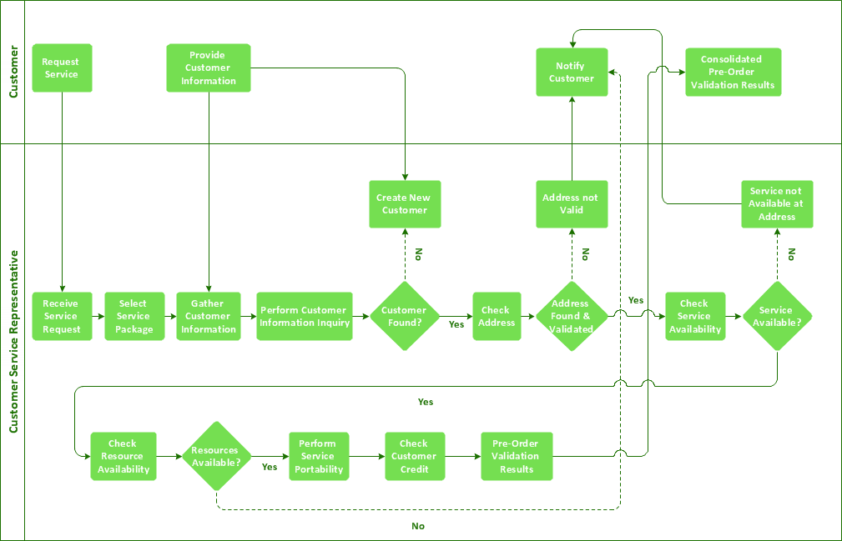

## Use Case Diagram

## User Interfaces

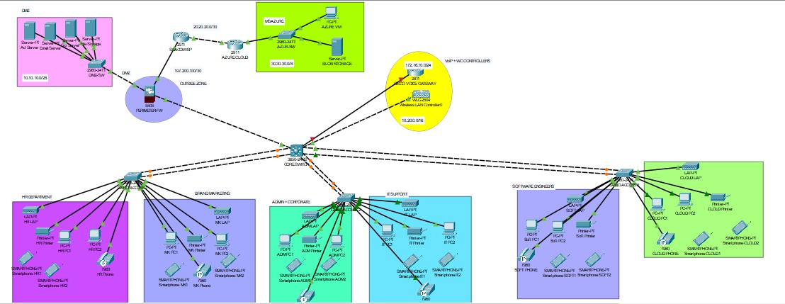

## Commands

### Switch Initial Config:

en config t

hostname cisco

enable password cisc0

banner motd ”Unauthorized Access is punishable by law ‘ no ip domain lookup

line console 0 password cisco login

exit

service password-encryption

### VLAN Assignment MultiLayer:

vlan 50

vlan 60

vlan 101

int range gig1/0/2-7 switchport mode trunk exit

### Multi-layers Switch Initial Config:

en config t

hostname Cairo-SW1 enable password cisco

banner motd “Unauthorized Access is punishable by law” no ip domain lookup

line console 0 password cisco login exit

service password-encryption ip domain name cisco.net username admin password cisco

exit do wr

### Router Initial Config:

en config t

hostname Voip-Router enable password cisco

banner motd “unauthorized access is punishable by law” no ip domain lookup

line console 0 password cisco login

exit

service password-encryption ip domain name cisco.net username cisco password cisco

## Conclusions and further work

The Telecommunication Company Network System will offer a range of functionalities to meet the diverse needs of the telecommunications industry. These include real-time network monitoring, automated fault detection and resolution, Quality of Service (QoS) optimization, and dynamic resource allocation. Additionally, the system will support secure data transmission, efficient routing, and seamless integration with emerging technologies.

# REFERENCES

* + Computer Networking: Principles, Protocols and Practice" by Olivier Bonaventure:
  + "Data Communications and Networking" by Behrouz A. Forouzan:
  + "Computer Networks" by Andrew S. Tanenbaum and David J.
  + <https://www.juniper.net/gb/en/training.html>
  + <https://www.netacad.com/>
  + <https://www.telecoms.com/>
  + https://[www.itu.int/en/ITU-T/Pages/default.aspx](http://www.itu.int/en/ITU-T/Pages/default.aspx)
  + <https://www.netacad.com/>
  + <https://learningnetwork.cisco.com/>
  + <https://community.cisco.com/>
  + [https://www.academia.edu/39704348/SIMULATION_OF_AN_ENTERPRISE_NETWORK_](https://www.academia.edu/39704348/SIMULATION_OF_AN_ENTERPRISE_NETWORK_WITH_THE_USE_OF_PACKET_TRACER_USING_VIRTUAL_LOCAL_AREA_NETWORK_VLAN_CONCEPT) [WI](https://www.academia.edu/39704348/SIMULATION_OF_AN_ENTERPRISE_NETWORK_WITH_THE_USE_OF_PACKET_TRACER_USING_VIRTUAL_LOCAL_AREA_NETWORK_VLAN_CONCEPT) [TH_THE_USE_OF_PACKET_TRACER_USING_VIRTUAL_LOCAL_AREA_NETWORK_V](https://www.academia.edu/39704348/SIMULATION_OF_AN_ENTERPRISE_NETWORK_WITH_THE_USE_OF_PACKET_TRACER_USING_VIRTUAL_LOCAL_AREA_NETWORK_VLAN_CONCEPT) [LAN_CONCEPT](https://www.academia.edu/39704348/SIMULATION_OF_AN_ENTERPRISE_NETWORK_WITH_THE_USE_OF_PACKET_TRACER_USING_VIRTUAL_LOCAL_AREA_NETWORK_VLAN_CONCEPT)